Syllabus for Mid Sem

The syllabus for the upcoming MID SEM examination includes the topics discussed from **live Contact session 1 to 8**.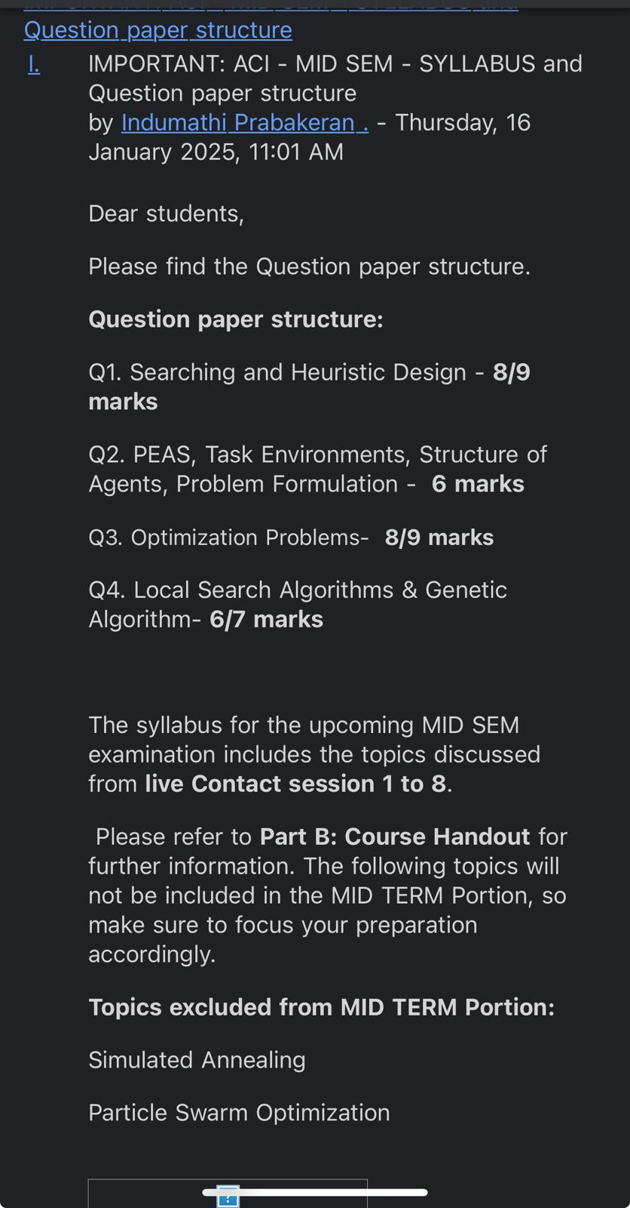

Please refer to **Part B: Course Handout** for further information. The following topics will not be included in the MID TERM Portion, so make sure to focus your preparation accordingly.

**Topics excluded from MID TERM Portion:**

**Simulated Annealing**

**Particle Swarm Optimization**